**Agile Development Workflow**

Praeses followed agile development methodologies (Scrum) with this GSA ADS prototype. The agile approach is centered on the concept of delivering workable software in short increments (“sprints”) in constant collaboration with the customer. This contrasts with the Waterfall approach, which typically generates long, sequential phases of software delivery, which, if off the mark (for example, in defining requirements), often causes considerable delays and added cost in the deployment of a solution.

Praeses utilizes specific processes to enforce good software development and project management principles including code standardization, build automation and integrated testing, all of which form key components of our disciplined software development process. These processes have been documented in relevant Attachments and our GitHub repository, per RFQ instructions.

This document is intended to demonstrate portions of our agile project management workflow, which was used in developing the GSA ADS prototype, as shown in the embedded Jira screenshots.

Once the Product Vision was established (respond to the GSA ADS RFQ by delivering a working prototype of a tool to report on drug events using the openFDA dataset) a Product Roadmap was developed which included identification of features and user stories. These were groomed from the Product Backlog in an initial Release Planning session. Figure 1 shows the planned sprints (with initial sprint cycle of 24 hours shown), epics (“Project Setup”) and initial story point estimates. This screenshot shows all product backlog items moved into sprints.

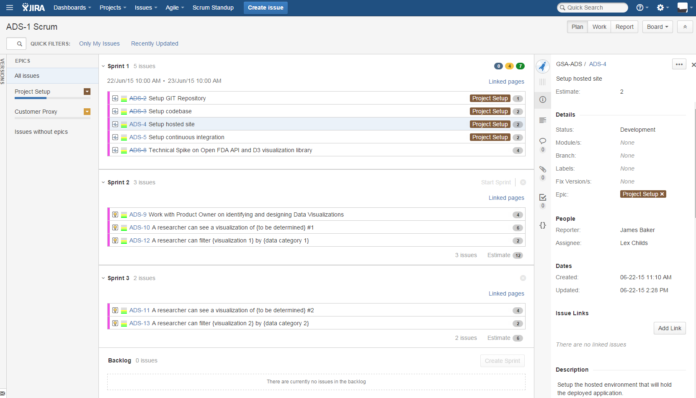

Figure 1. Product backlog development leading to Release Planning

Planning continued down to the Daily level through daily stand-up meetings of the scrum team. A portion of the stand-up notes are captured in Figure 2 and are intended to convey what a team member did yesterday, what they plan to do today and what impediments are blocking them (if any).

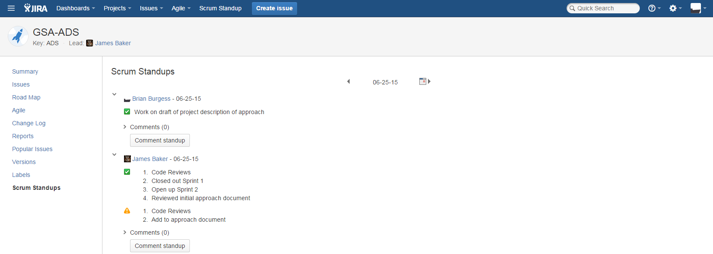

Figure 2. Example of daily stand-up notes.

The ScrumMaster created four boards within Jira to enable the workflow using the ADS (Agile Delivery Services) label to help specify the project: ADS-1 Scrum, ADS-2 Planning, ADS-3 Development and ADS-4 Release.

Figure 3 shows the Scrum board (ADS-1 Scrum) lists the stories as they are being planned to work – the stories are moved across the columns (further requirements established as needed) until finally “Done” (ready for planning/design).

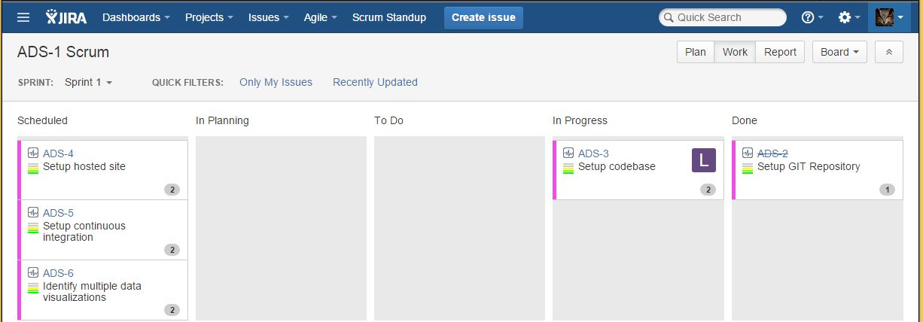

Figure 3. Scrum board showing initial planning workflow of stories

The Planning board (ADS-2 Planning) is used to complete the design process for each story (Figure 4) with the final column of “Design Done” implying the story is ready for coding.

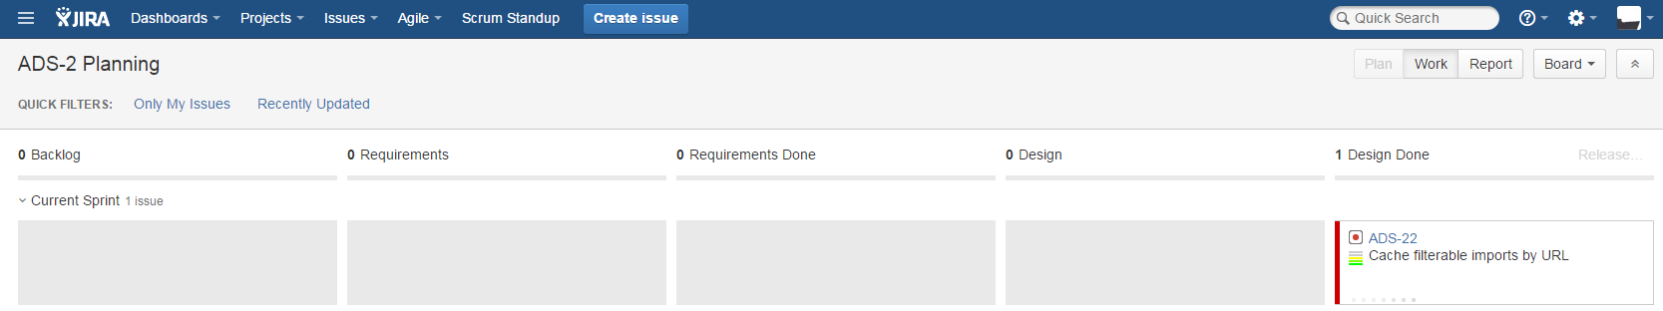

Figure 4. Planning board - Design done indicates a story is ready for coding

The development board (ADS-3 Development) comprising 7 different columns is shown in Figure 5. A developer grabs a story from the first column (“Design Done”) and moves it to “Development” indicating they are coding that story. Once coding is complete, the developer moves the story to “Development Done” where it is ready for code (peer) review by another developer. Once the code review is completed (and the story moved to “Peer Review Done”) the story is grabbed for testing (“Business Review”) by a tester, Product Owner or another developer depending on the particular scrum team. Once testing is completed (“Business Review Done”) the story is ready for the Release cycle.

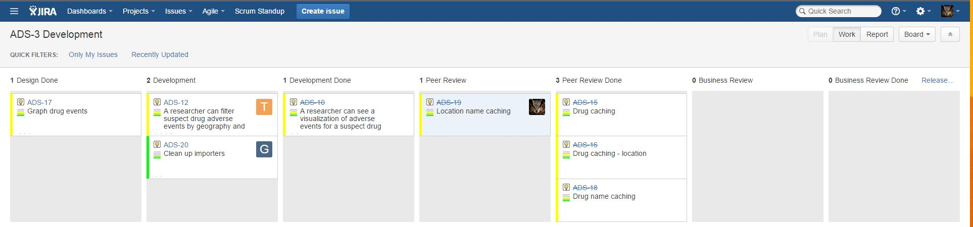

Figure 5. Development board - Stories go through coding, peer review and business review (testing) and are then ready for the release process

The final board used by the project team is the Release board (ADS-4 Release). As shown in Figure 6, this board is comprised of four columns and is intended as the final testing for each story such that acceptance criteria are met (the story is “done done”). Once the stories are completed on this board (“Done” column), the Release process for all stories in the given Sprint commences.

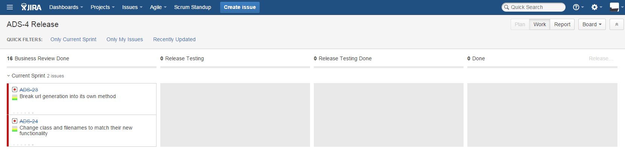

Figure 6. Release board - final output is all stories ready to be released

All activities of the scrum team are captured within Jira as shown in Figure 7.

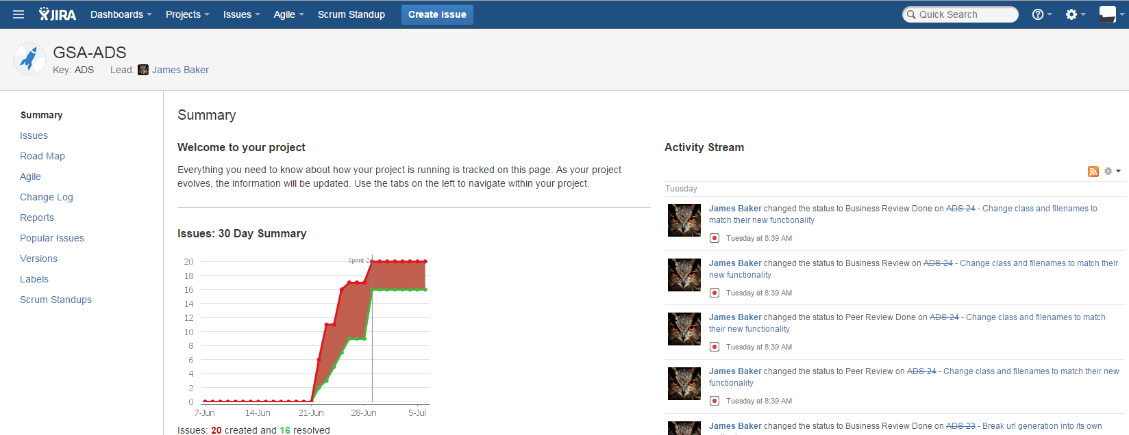

Figure 7. Project summary including log (activity stream)

After the a release is done (Figure 6 above) then that given Sprint is closed in Jira and a new one made current with the team conducting a retrospective of the just-completed Sprint and planning session for the new one. Figure 8 shows the final Sprint for our GSA ADS prototype development.

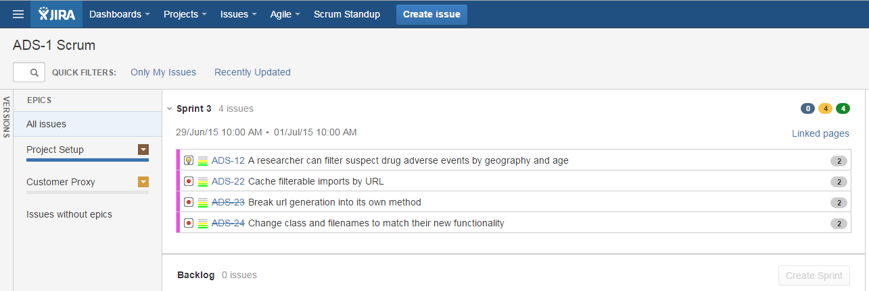

Figure 8. Final sprint for the GSA ADS prototype development